# Color Palette for Andrew Joseph Alexander

Option 1

**Link:** <http://www.colourlovers.com/palette/349046/North_Northwest>

**Screenshot of Color Palette for Andrew Joseph Alexander:**

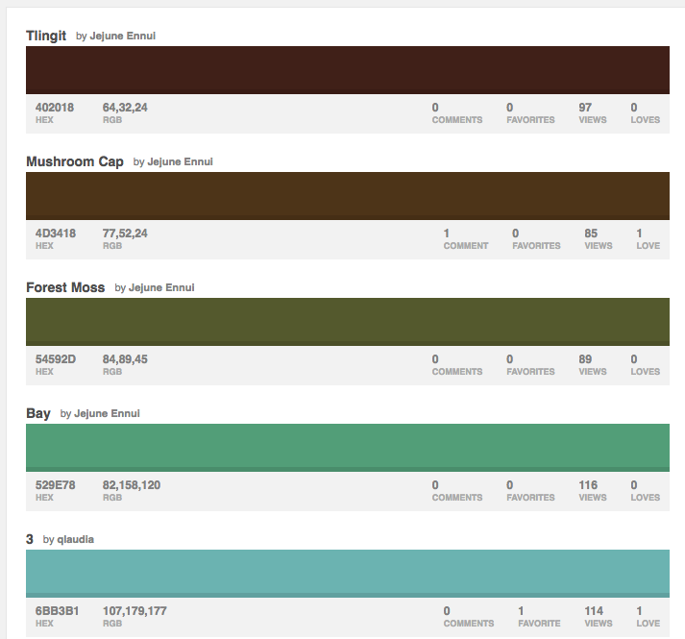

Option 2: Colors picked from AJA.com & Adobe Tools

**Link:** <https://color.adobe.com/cloud/aHR0cHM6Ly9jYy1hcGktYXNzZXRzLmFkb2JlLmlv/my/libraries/all>

**Screen Shot:** 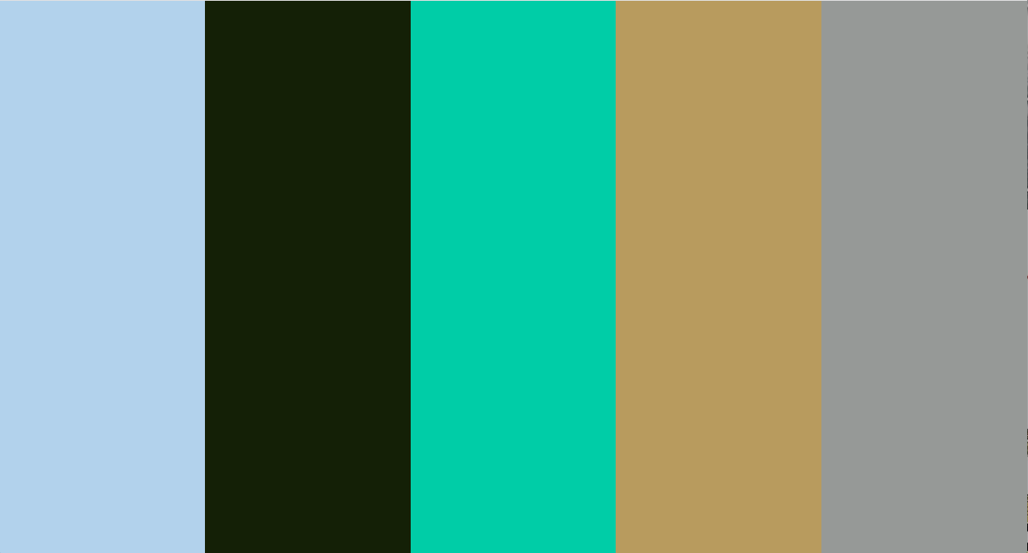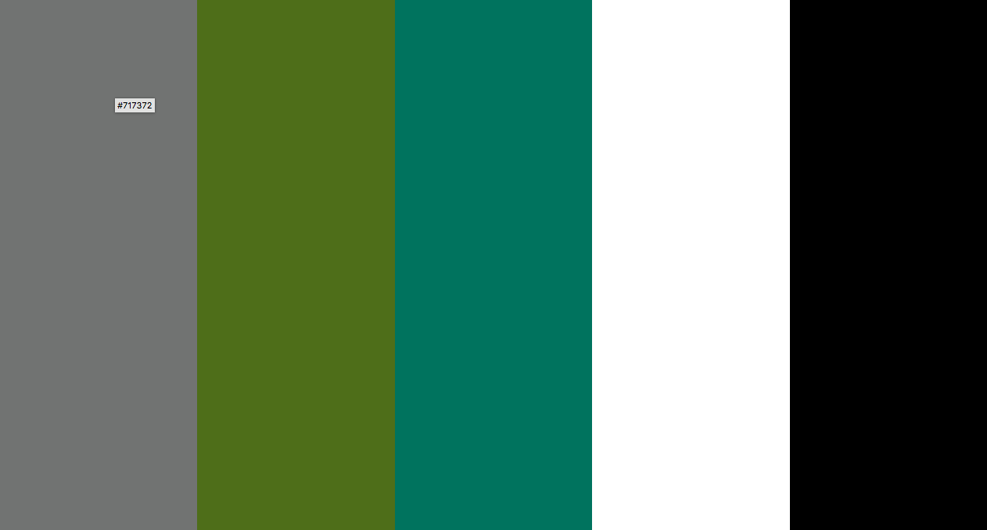

**Hexadecimal Color Values (Hex. #):**

#### Color 1 - (#) B2D2EC

#### Color 2 - (#) 142006

#### Color 3 - (#) 00CDA7

#### Color 4 - (#) B89B5E

#### Color 5 - (#) 969997

#### Color 6- (#) 717372

#### Color 7 - (#) 4E6E19

#### Color 8 - (#) 00735E

Generic #FFFFFF - white and #000000 - black

Option 3

**Link:** <https://www.design-seeds.com/wander/wanderlust/color-view-65/>

**Screen Shot:** 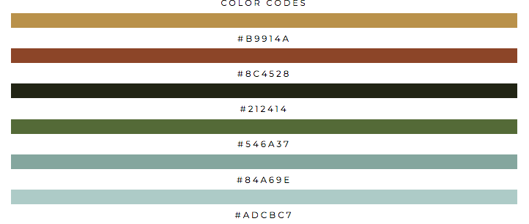

**Hexadecimal Color Values (Hex. #): Above in screenshot.**

My inspiration came from reviewing past documents I've completed during the waterfall design process, as well as the original RFP. These colors are a good choice for Andrew Alexander's web interface because I kept the end users experience in mind along with the content they're viewing. This color palette will also contribute a to clean and aesthetically pleasing design, since the colors complement each other in regards to contrast.